Notes 1-20

Layering & Layered Software:

* Layers of layers will implement the network
* The higher layers will not depend on how the lower layers do their job
  + This is an important property to limit breakage
* A lower layer is not going to depend upon the type of information that the higher layer sends down to it
  + The lower layer is going to treat everything that the higher layer sends as data and does not care what it means

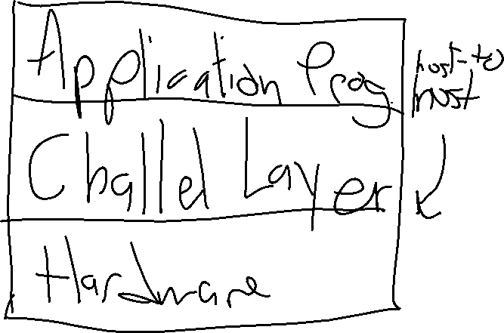

Just an example of how layers could work.

* There are different ways you can set up the layers
* Each layer is called a ‘protocol’
* The collection of protocols is a protocol-suite/stack

Protocol:

* Rules for formats for communication between peers that defines the meaning and validity of messages

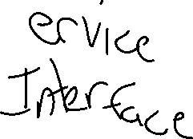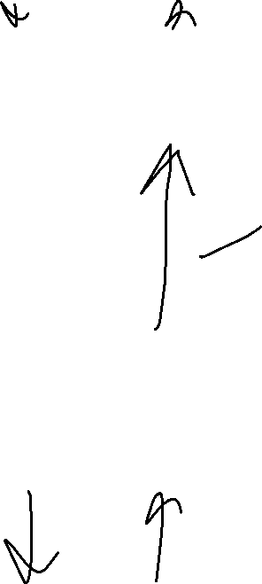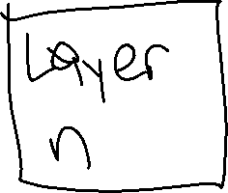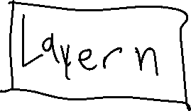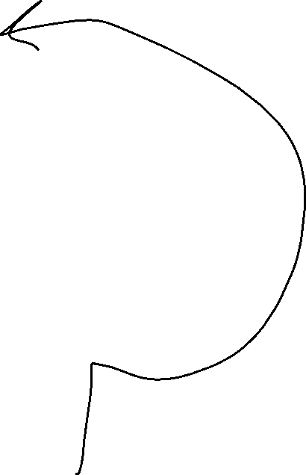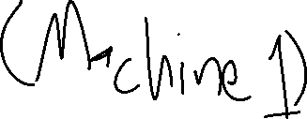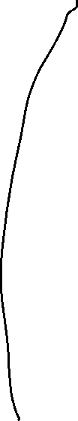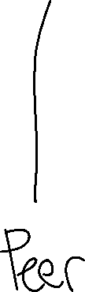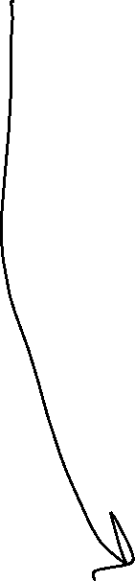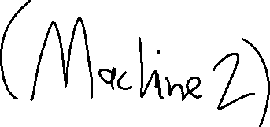

* Layer n talks to layer n (what it believes) through a peer interface
* Data is sent to layer n+1 and we will add a header
  + A header is used in the mitigation process for the peer layer (could be how long the message is or some kind of information)
  + It will be the layer n+1 header and will actually go on the front of the data
* That data is sent to layer n and layer n just takes the information as data
  + Layer n will stick its own header in front of the n+1 header.
* It then goes through the peer interface
  + The process above is encapsulation
* After it goes through the peer interface, it will start taking off the headers as the data goes up the other protocol layers

TCP/IP v4

* 7 layer model (OSI Model)
  + Application: Services that are exposed to the applications / programs
  + Presentation: Gives us the ability to handle different data formats.
  + Session: Provides a namespace to manage message streams.
  + Transport: Process to process communication. Bits are organized as messages (ports)
  + Network: Handles connection between nodes (device connected to the network/host). Organizing packets
  + Data Link: group bits into frames. Organized into frames (collection of bits). Gives us reliable delivery
  + Physical: handles raw bits on the ‘wire’